Novir Steering Group Meeting 8.2.2022 kl 11:00-13:00
Present: Josefin Svedin (chairwoman), Elfa Svanhildur Hermannsdóttir, Anne Lise Solstad, Estella Björnsson, Rune Johnsen, Minkkinen Mika, Berit Houmølle
- Each country tells the latest and most current news from their own country:
  - Norway, has a large structural change going on, with Statped to bring competence closer to the child.
  - Denmark, their services are put up for competition this year. Bidding process from April-August 2022.
  - Iceland are under still under Social welfare ministry. Still responsible for the guide dogs service in Iceland. Working on how to make distance visits more effective, how to take advantage of distance consulting. Arranging a RIWC conference in June 2022 (https://riwc2022.is/ ).
  - Finland, the state now pays a larger part of the price of Valteris services, up from 50 to 70 percent (2022-2025).
The assigned task / role of Novir steering group
Suggestion:
The Novir steering group is a small group that enables things to advance more quickly and is able to meet more frequently.
The task is to:
    - Establish and maintain, coordinate and lead the networks within Novir
    - Keep an eye on the relevant issues regarding visual impairment
    - Plan for a bigger Novir (conference?) every second / third year
The Novir steering group makes a frame for the work and collaboration within the Novir networks. According to the frame the network shares knowledges, develops and cooperate within the group. The network yearly presents a plan and goals for the incoming year to the steering group and the steering group follows up the work. Every network has a contact person in the steering group.
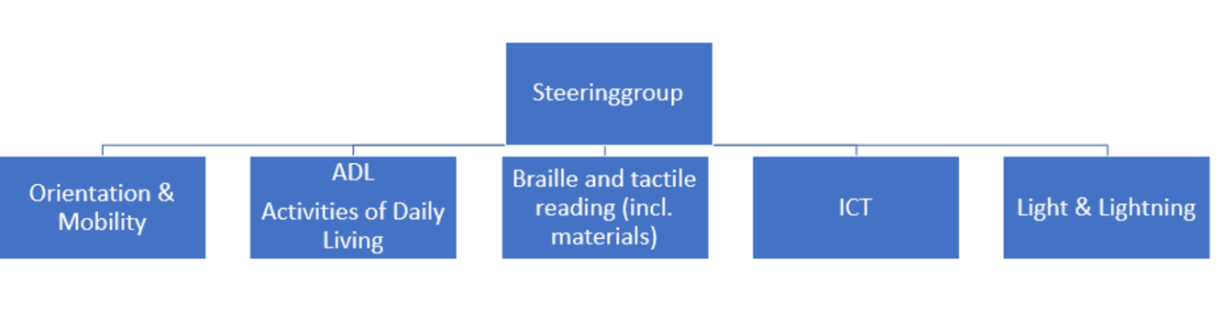
  - The danish model (picture) will be used as a foundation and developed until the next meeting. Every member of the steering group will take the Danish model into discussion within the own organization to approve it as it is or make suggestions for how we can develop the model to make it work for Novir.

Other thoughts:
  - The steering group could have an activity plan for a longer period, for example 3 years.
  - The homepage will be discussed during the next meeting.

- What platform can be used for the Novir cooperation
  - The steering group chose Teams as a platform.
  - One main Novir Teams group, channels for the different networks, the steering group will have access to all the groups and the members in the different networks will also have access to all the information. Openness is something that we should strive for.
  - Norway will be in charge of creating a Novir-platform in Teams.
- Next meeting: Monday 13th of June 2022 13-15 Finnish time.
  - Topics Statped update, green light the structure and task of Novir Steering group, the homepage, the activity plan for steering group, frame for the networks (Finland makes a suggestion of the frame)

