Novir Steering Group Meeting 26.8.2022 kl 13:00-15:00
Present: Josefin Svedin (chairwoman), Elisabet Sepulveda, Annika Södergren, Elfa Svanhildur Hermannsdóttir, Anne Lise Solstad, Estella Björnsson, Minkkinen Mika, Kenneth Hartman
- Each country tells the latest and most current news from their own country:
  - Norway: Norway has had a large structural change going on (see the Power Point presentation) and the process is still going on. Also laws have been changed. Many professionals are going to retire quite soon.
  - Denmark: Services are put up for competition this year. Bidding process from April-August 2022. This time contract is only for two years.
  - Iceland: Laws according education and children are going to change. It´s important that visually impaired children are not forgotten in those changes.
  - Sweden: Many professionals have retired (Elisabet is going to retire in december). There are organizational changes going on. Changes are not going to be so big, more details in the beginning of the next year. Latest law changes have affected positive for blind pupils (braille reading).
  - Finland: At the moment no big changes going on. Valteri has broadened the expertise in vision so that all of our bigger units can provide counselling regarding pupils with a visual impairment.
- Structure and task of Novir Steering group
Suggestion:
- The steering group is a smaller group to make things advance more quickly and to be able to meet more frequently.
- Every country has 2 representants in the steering group
- The task is to steer, coordinate and plan collaborations
  - Keep an eye on the relevant issues (locally) regarding visual impairment
  - Sets task for the smaller groups/networks
  - Meet in-between the bigger Novir meetings (every second year) = online conference with every network represented?
- The steering group has an activity plan for a longer period, for example 3 years.

- Steering group and networks

Suggestion:
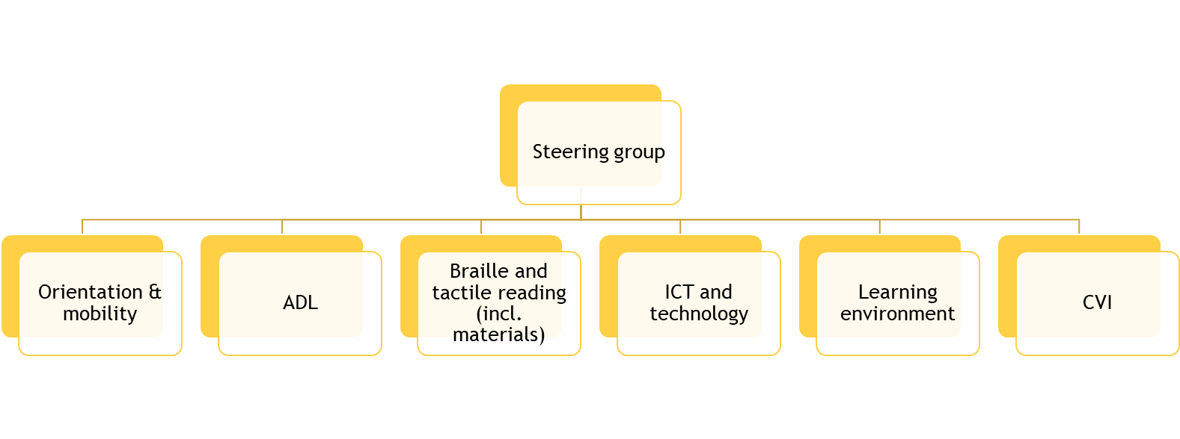

- The task is to develop, maintain, share knowledge.
- The network is lead by the head of the network
- The head of the network presents a plan for the next year for the steering group to get a green light and feedback
  - Contacts can be taken also within a year: for example different kind of questions)
- Every country has 1 official representative for every network, the group may be bigger when needed

Discussion:
- Suggestion: we add a network-box for psychologists
  - Psychologists from Sweden, Norway and Denmark have had meetings two times a year
  - What is the task for psychologists and what are they going to produce? This need clarification
- School subjects should be included in one of the networks
- We could start network one group at the time:
  - Braille and tactile reading
  - ICT and technology
- Since the psychologist-network is already existing, this could continue it´s work within as one official network even though we don´t have representants from all the countries.
  - We invite one of the psychologists to tell us how they have been working.
- Every member discusses within their organisation what the topics for Braille and tactile reading -network could work on.
- The discussion will continue in the next meeting.

- Novir and Teams (Anne Lise)
  - Anne Lise and Rune has prepared a Teams for Novir
  - At the moment there is one channel for the psychologists and for the steering group.
  - Agendas, protocols, and files can be saved there.

- Who will be the next ”host”
- Finland (this year)
- Norway (2023)

- Next meeting: 14.10. at 13.30-15 (Finnish time)
  - The discussion of the networks will continue
  - Homepage (Kenneth and Nanna)
  - One of the members from the network of psychologists tells us how they have been working (Anne Lise and Elisabet arranges).
- Before next meeting, remember “Every member discusses within their organisation what the topics for Braille and tactile reading -network could work on.”

