Minutes NOVIR meeting, 19th november 2021

Zoom meeting at 10-12 Swedish time

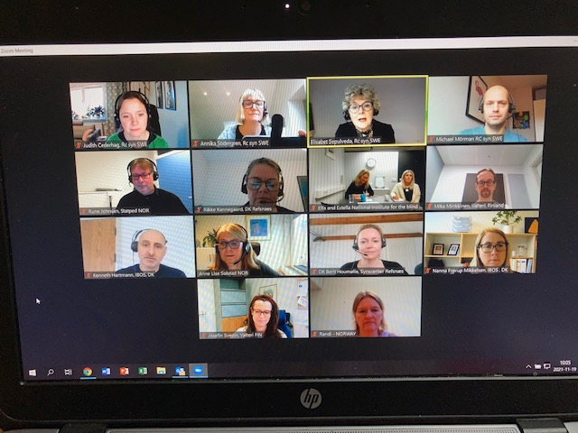

List of participants

**National Institute for the Blind, Visually Impaired and Deafblind, Island:**

Elfa Svanhildur Hermannsdottir

Estella Björnsson

**IBOS, the National Institute for the Blind and Partially Sighted, Denmark:**

Kenneth Hartmann

Nanna Frorup Mikkelsen

**Synscenter Refsnaes, Denmark:**

Berit Houmölle

Rikke Kannegaard

**Statped, Norway:**

Rune Johnsen

Anne Lise Solstad

Randi Kvåle

**Valteri Center for Learning and Counsulting, Finland**:

Josefin Svedin

Mika Minkkinen

**National Agency for Special Needs Education ans Schools, SPSM, Sweden:**

Elisabet Sepulveda

Michael Bergström Mörman

Judith Cederhag

Annika Södergren

Elisabet starts the meeting and welcomes everyone.

Michael continues to give at return to the meeting in May. The purpose of today´s meeting is for us to agree how we will organize Novir in the future.

If we are to have a steering group, how the website should work and how information should be shared. Also how often Novir should have meetings and in what way.

Michael presents a powerpoint with a proposal from Sweden on how Novir should be organized; Start a steering group with 1-2 members from each organization (at least one member participate each time). The purpose of this group is to enable Novir´s mandate.The steering group meet digitally twice a year.The steering group make sure that the professional and topic networks proceed. The networks reports needs and result to this group. Each meeting we have training co-operation on the agenda.The countries host meetings according to a preset schedule.

Based on the proposal, a group discussion in breakout rooms of 15 minutes followed.

From the group discussions:

Everyone agrees that a steering group needs to be formed. One group thought that 1 person from each country, another thought 1-2 persons from each country/organization. The steering group should consist of people at managerial level was a proposal. That they have a mandate to decide which groups will form networks.

Michael summarizes the proposals. The steering group shall consist of people from each country and organization. They should have a meeting digitally and we give them a mandate to decide further. We do a vote and everyone agreess that a steering group should be formed. **A short meeting to bee seen in the steering group is** **planned 16th december at 12 Swedish time. Send to Annika within 2-3 weeks who will participate so that Elisabet can send an invitation.**

We continue with the next area based on the powerpoint. May 2021: Gitte offered to manage the webadminstration. November 2021: Gitte is no longer in the organization, who has access to the website? Suggestion: Add page on the menu for annual reports from each organization. We determine a date for sending the report to X every year, each organization responsible individually. Add a page for ”Ongoing projects/networks” where we can publish information so everyone know which networks are up and running.

Based on the proposal a group discussion of 10 minutes followed.

From the group disussions;

IBOS in Denmark pays for the website. Thoughts that came up were; Who visit the website? Who is it for? How many visitors? Keeping the website up and running requires time and money. Maybe better with Teams or similar where we can chat between meetings.Links should be on the website to know what is going on within organizations and projects.That all countires in some way have the opportunity to post inforamation on the website.

Search words that lead to the webside and share in our countries. One suggestion was that the website should contain two parts, one for managers and one for employees. The steering group may continue to work on this.

Michael introduces us to the concluding part. This is the suggestion: The steering group meet up digitally twice a year. They plan for a physical meeting every third year. On this physical meeting the current agreement is evaluted and necessary changes are implemented. Networks meet digitally, and if some groups need to meet up physically they talk to their managers to arrange that.

Another discussion session for the groups for 8 minutes.

From the group discussions;

Psysical meetings are needed for the steering committee to be able to work together. A proposal to have two digital meetings per year and 1 psysical meeting. Every three years, Novir conducts a conference based on a specific theme. Another group suggested that the steering group meet physically every two years. Should be a link to the steering group from networks and also to the webside to share the work from networks.

Michael and Elisabet ends the meeting. **Everyone goes back to their organization and then sends name to Annika on people who will be part of the steering group**. **Elisabet invites to a first meeting 16th December at 12 Swedish time.**

*At the computer Annika Södergren*